NGL DONATION TO EWUSIEJOE FLOOD VICTIMS
On Thursday 22nd June 2023, residents of Ewusiejoe were displaced due to heavy downpours that persisted for three days. Management of the Company donated 59 mattresses, 10 bags of 25kg rice, 40 pieces of mosquito nets, and one drum of palm oil to the residents of Ewusiejo as the Company's support to bring relief to the displaced residents.
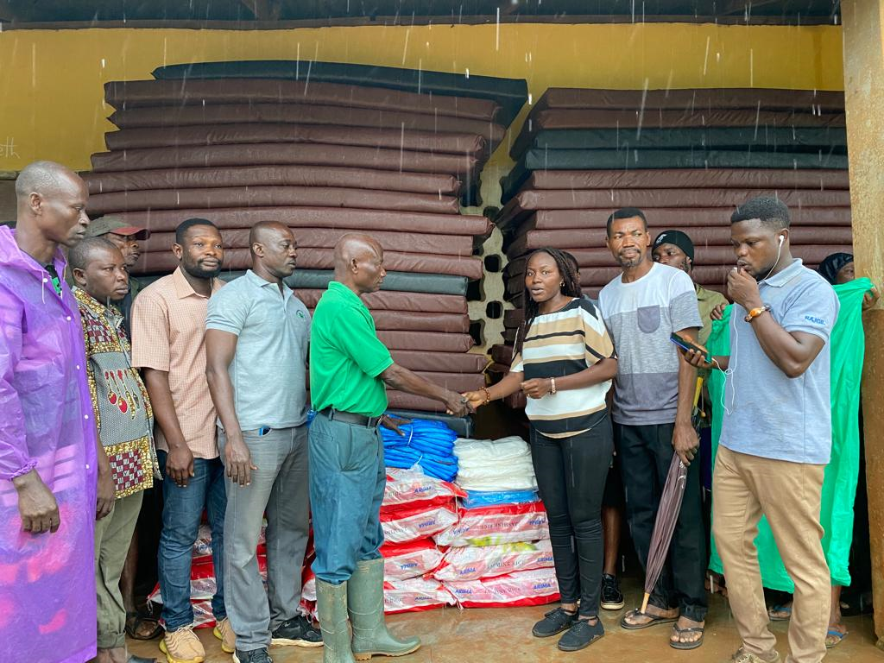
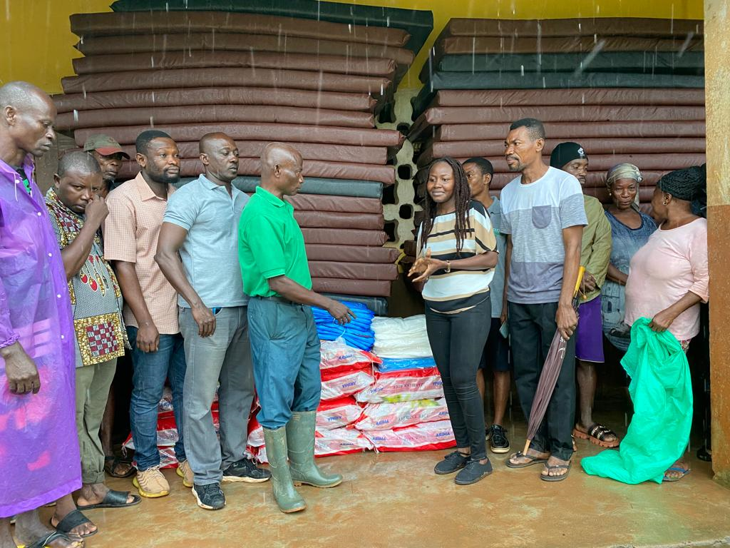

CPO DISTRIBUTION TO SCHOOLS
As part of the Company’s support to Education, the Company has been supplying Palm Oil for feeding students of some selected government–assisted Senior High Schools and Training institutions within the Company’s catchment area since 2008.
The distribution for 2023 was done on May 26th at the HWTC for 20 institutions made up of 14 government-assisted Senior High Schools and 2 Nursing Training Institutions.
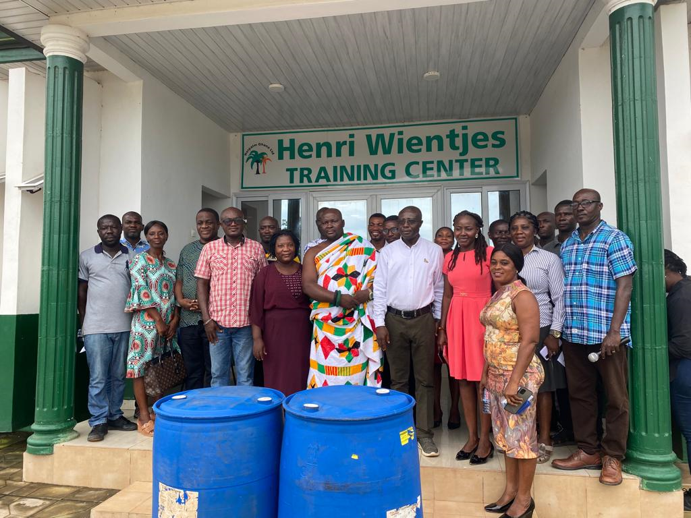
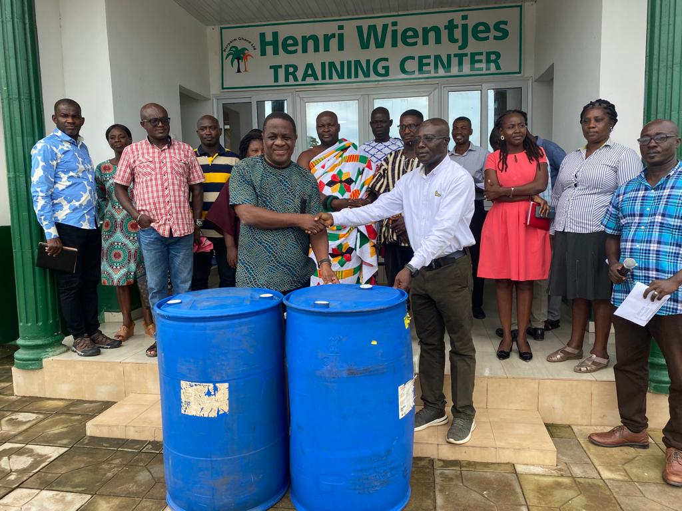

STAKEHOLDERS ENGAGEMENT
To ensure the Company continuously enjoys operational peace, management engages the landowning communities on matters of interest to both the Communities and the Company. the 2023 stakeholders engagement was organized on July 26, 2023, at the HWTC.
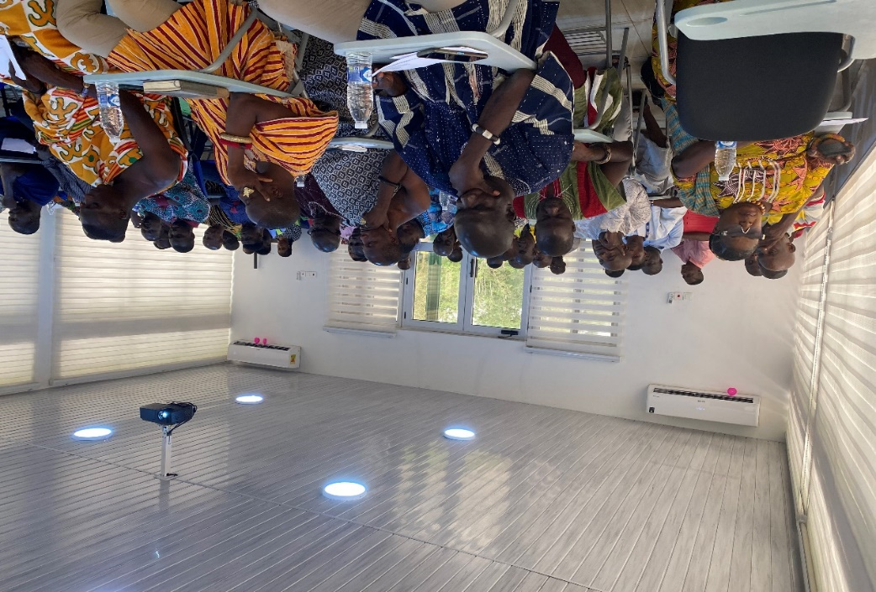
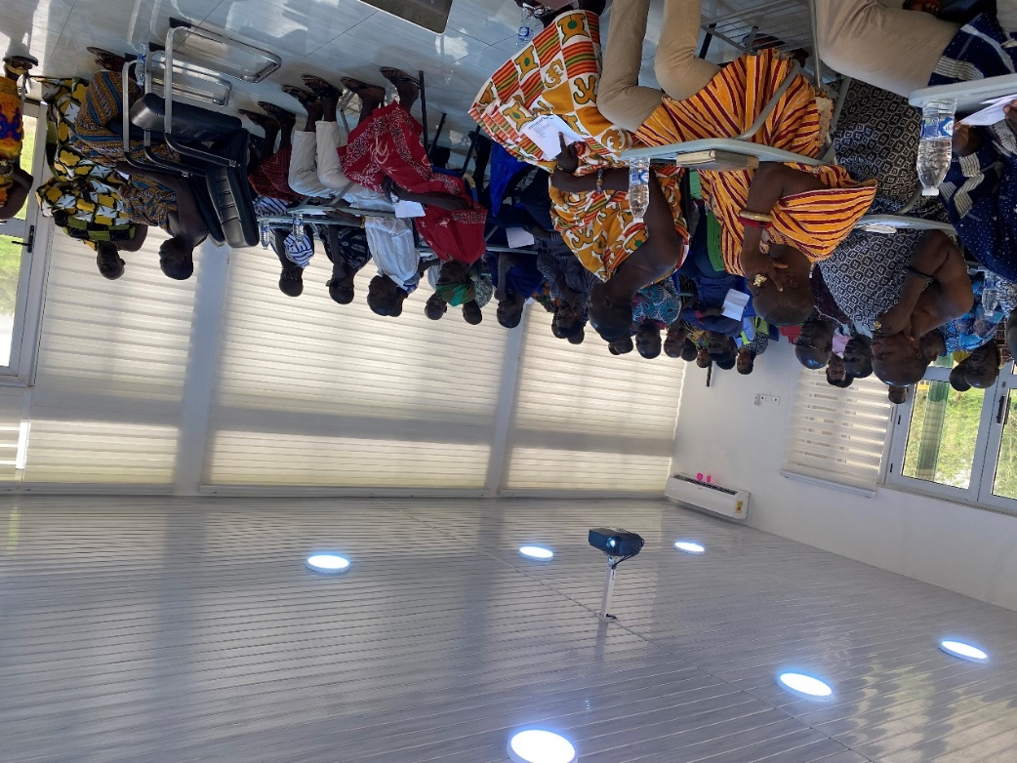

COMMUNITY ENGAGEMENT
The community relations officer visits the land-owning communities to brief them on policies and solicit concerns that they may have.
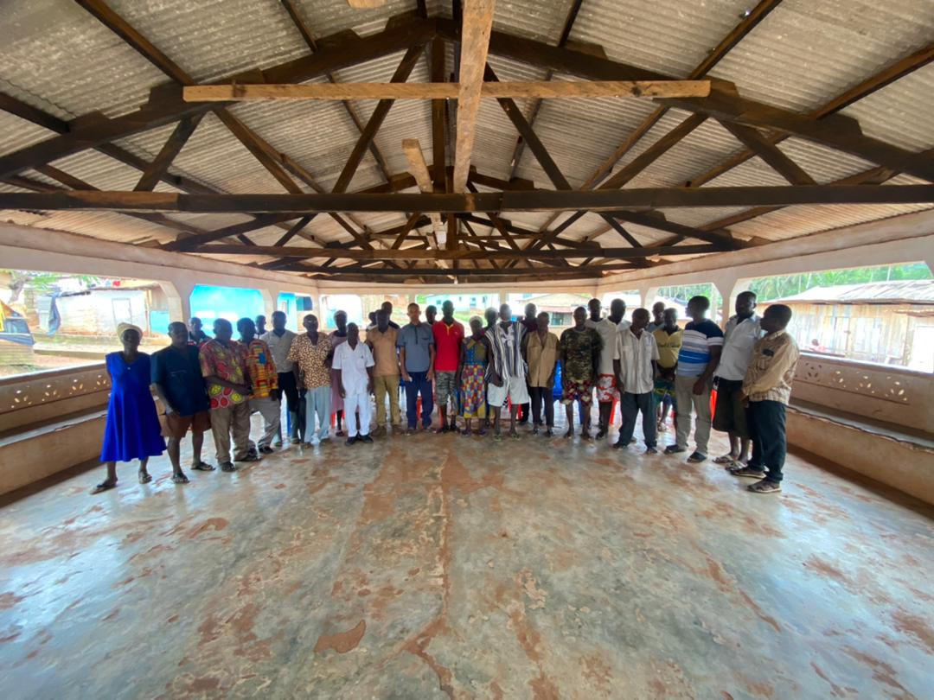
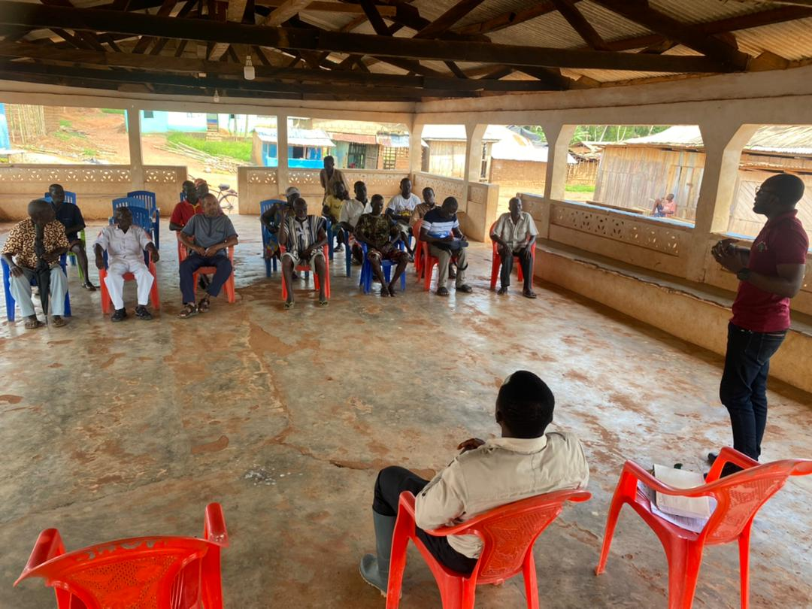

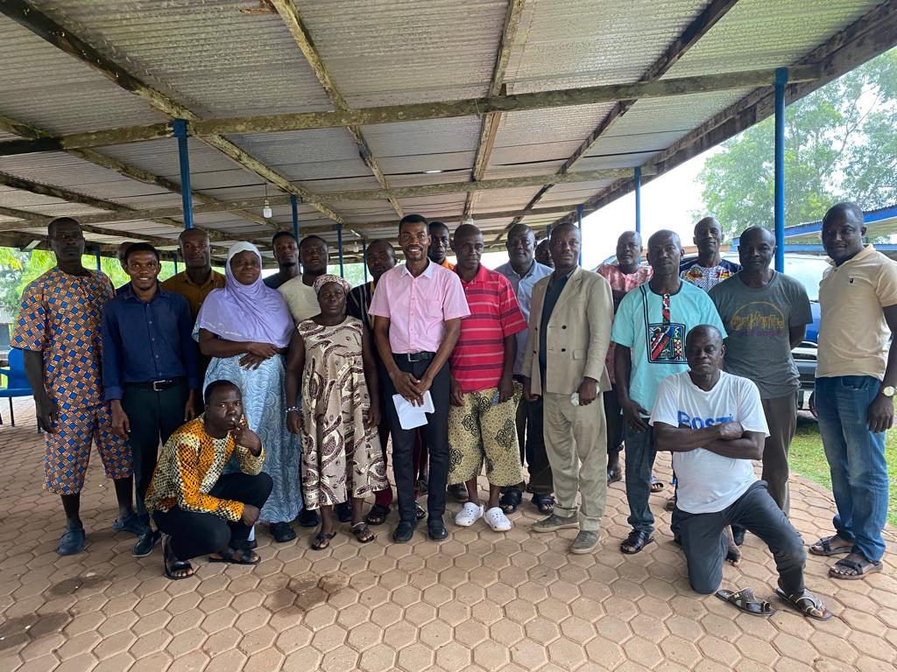
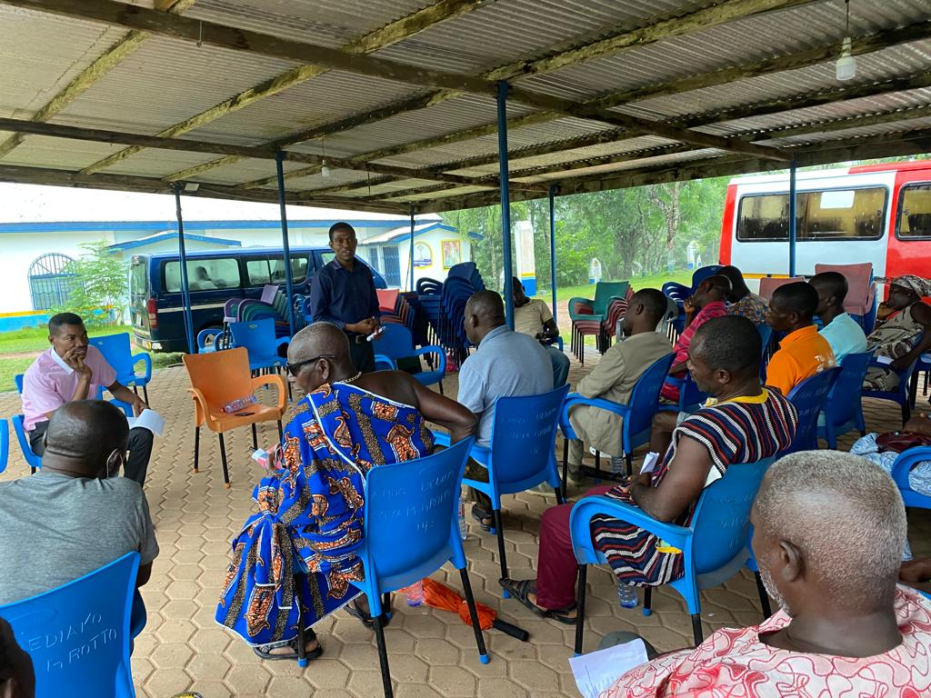

NGL QUARTERLY STAFF DURBAR
Management has instituted a quarterly staff durbar to create an avenue for Staff and Management to interact, and address key issues bothering the organization by find lasting solutions to such concerns to enhance productivity.
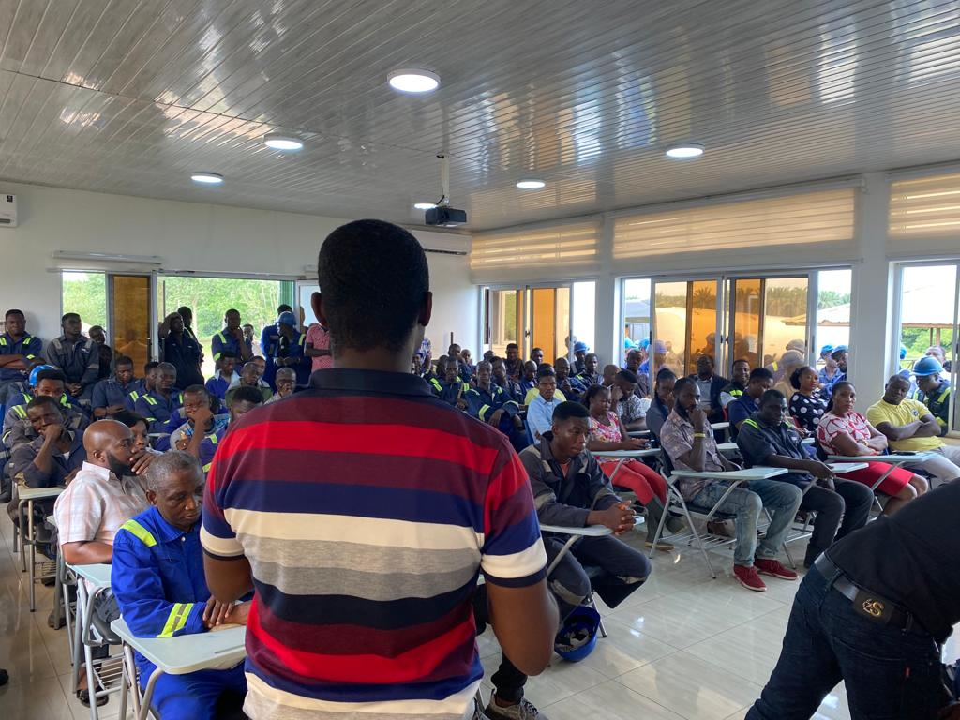

WORKERS FUN GAMES
As part of Management's effort to boost employee morale and improve employee engagement an employee game was organized on 4th August 2023 at the 2BN park Apramdo.
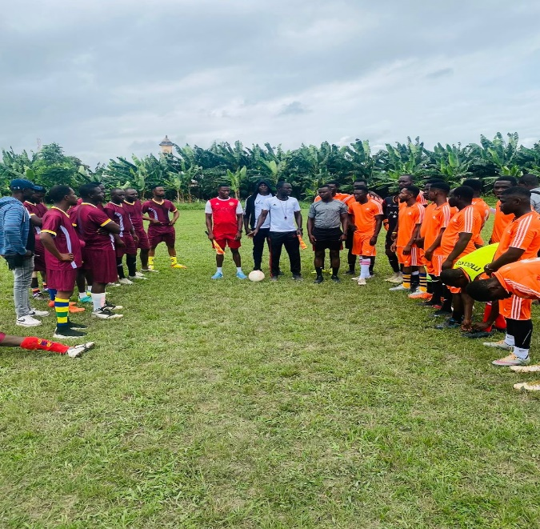
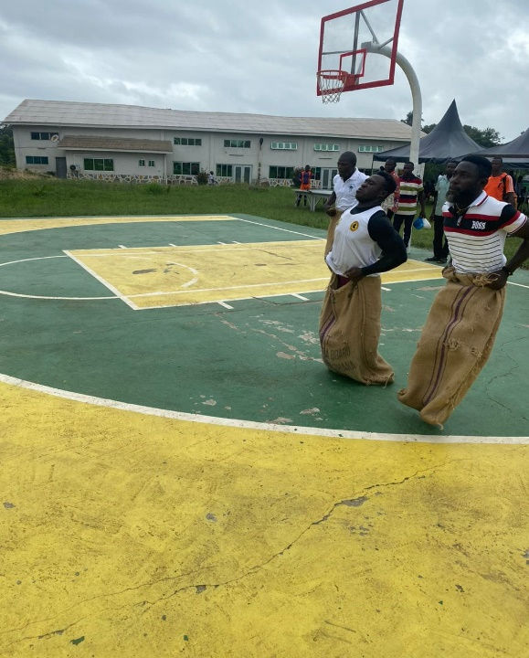
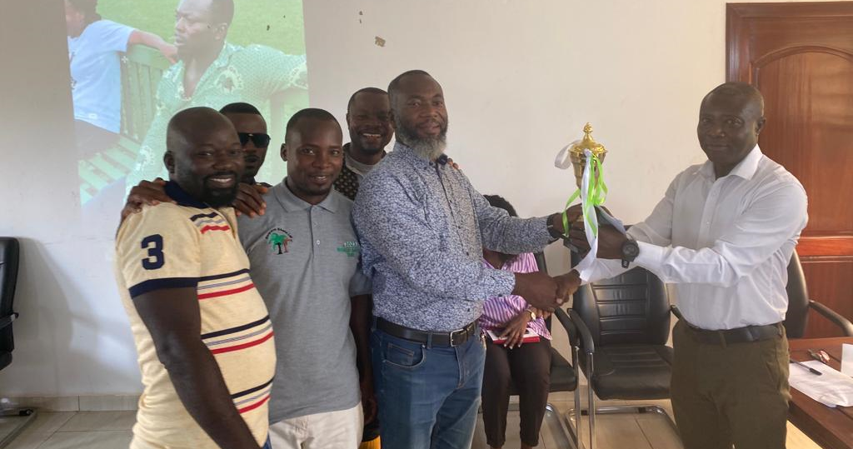

COURTESY CALL BY THE HOTOPO DIVISION
Members of the Hotopo Divisional Council led by the Divisional Chief Nana Nwianwia IV paid a visit to NGL to discuss issues of interest. The Hotopo division is the largest land-owning stakeholder to NGL in the Ahanta-West district.
